

Nanoplatforms for Neuroscience— NeuroNanotech

Deliverable Number

Name of deliverable

Lead Beneficiary | Name of lead beneficiary
Dissemination level | Public/Sensitive
Version | V1

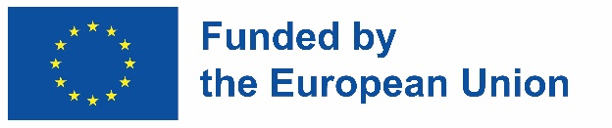

Document Information

Grant Agreement Number | 10116935
Project acronym | NeuroNanotech
Start date of project (Duration) | 01/01/2025 (48 months)
Deliverable lead | Name of lead beneficiary
Deliverable number | Deliverable number
Deliverable name | Name of deliverable
WP | Number and name of WP
Dissemination level | PU – Public/ SEN - Sensitive

History of changes
Version | Date | Author | Comments / Changes | Pages

EXECUTIVE SUMMARY

